**Oreti Totara Dune Forest Report Dec 2023/Jan 24**

**Revegetation**

Track mowing to get better access to the western basins has been done. Trees planted in the past have been released from grasses and lupins where necessary.

Here is an interesting map of the reserve area in 1864. It shows the area beside the river that did not have trees on it at that time. Suggesting it will be difficult to establish a forest in this area.

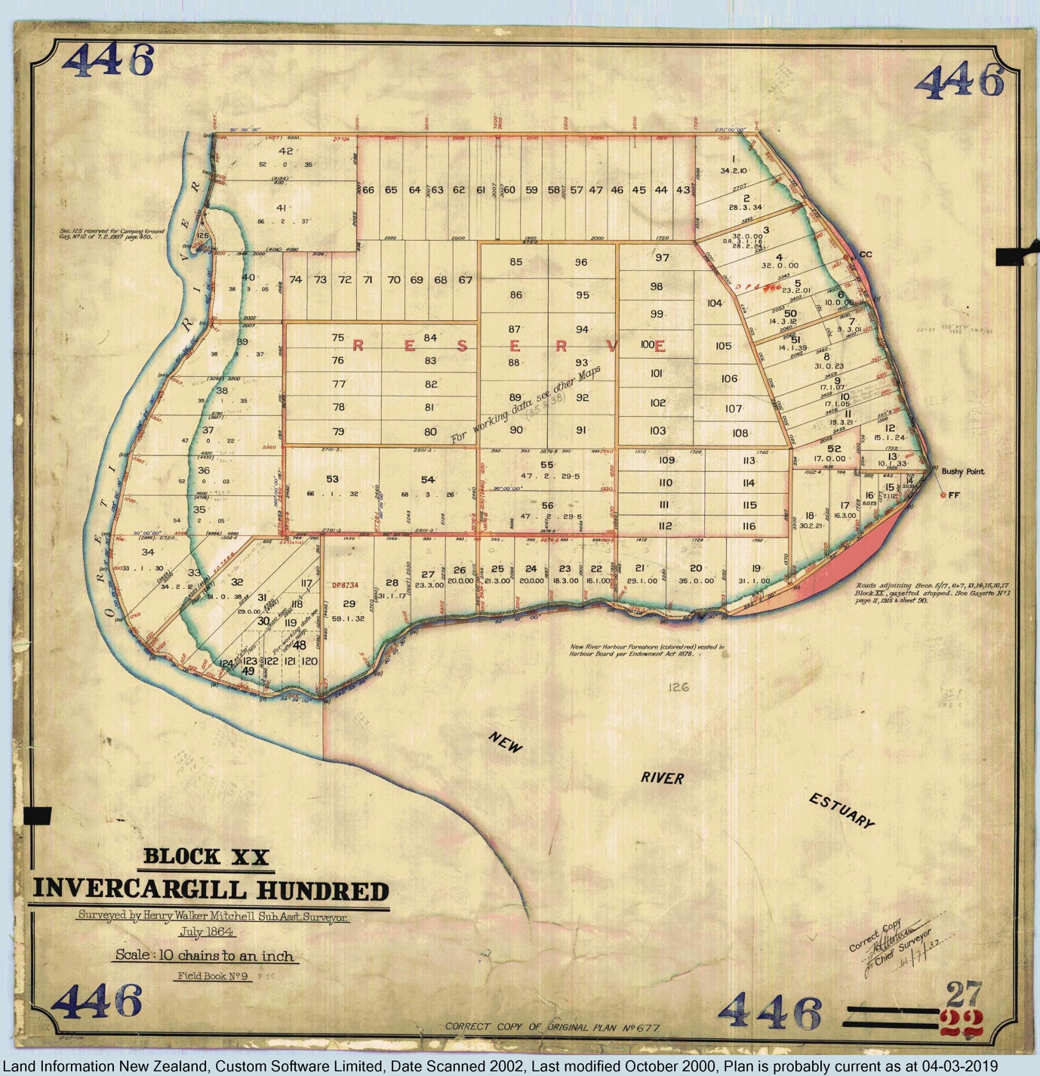

Summer Student report.

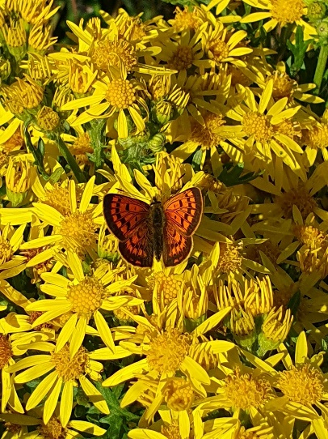Kia Ora!   
My name is Elizabeth and I’m Wildlife Management Masters student at Otago University. My master’s placement is taking place out at Ōreti Totara Dune Forest (OTDF) reserve in Ōtātara, and is based around doing baseline skink and invertebrate monitoring, along with doing another summer bird count (to be compared to the 2021 bird count). I’m also doing some weeding (Chilean Flame Creeper-CFC), and releasing of trees along with the monitoring. I’ve been pretty busy! My time on OTDF started in the last week of November, and as of this week (end of January) I will have done 9 weeks of monitoring and weeding on the reserve.

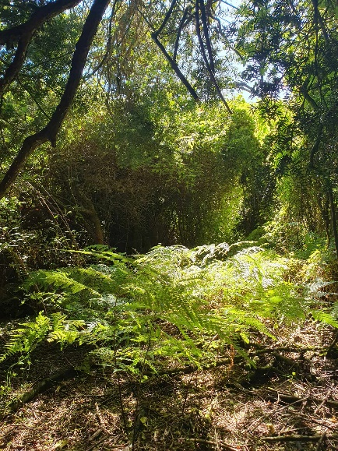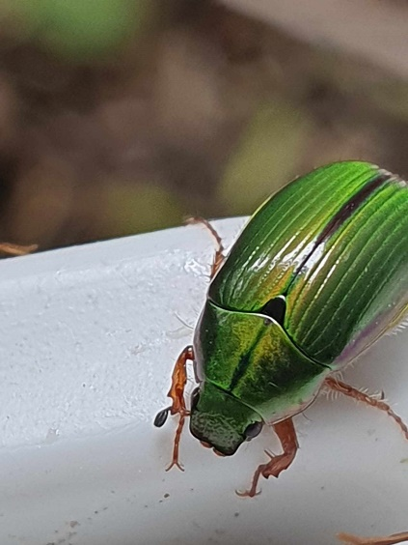There are a few main spots I have focused on for weeding the CFC. One of the major spots is in the North East corner of the reserve, where two totara trees were engulfed with the weed. Another large section is within the Manuka Jungle and on the Manuka Jungle track. This area still has a fair amount currently - but it is mainly off the track now. The third larger section is in the forest across from the new seat on the MingiMingi trail. This section can not be seen from the path, but there is quite a large area of CFC in there (a little less now though!). The last larger section is within the Totara/Matai Forest, off the path and heading deeper into the forest (away from the fence). This CFC is tied up with another ground weed which makes it harder to get to the roots, but a decent amount has been removed from there. Smaller sections include areas along the path where I have seen CFC popping up, mainly along the MingiMingi trail, but also a few places within the Totara/Matai Forest. These sections have been cleared entirely, and hopefully will stay cleared (unless some pesky roots remain).

The bird counts I’ve been doing is using the same stations as the previous counts (9 stations throughout the reserve). I’ve seen a few interesting birds, and it’s looking as if I am seeing more species this summer than what was recorded during the last bird count. For example, I am seeing more brown creeper in my counts than previous ones, along with more yellowhammers, tuis, bellbirds and silvereyes. There are also been quite a few shags visiting the pond, and even a white-faced heron. I won’t know the details until I statistically analyse everything, but its looking good!

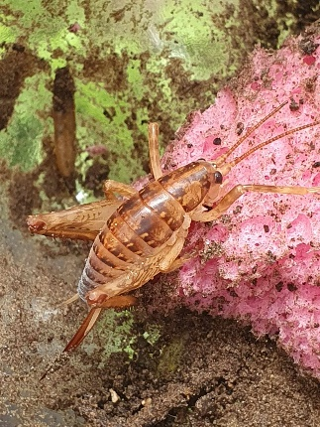I’ve been monitoring the ground invertebrates using pitfalls (containers in the ground), and have lines of these set up within different habitat types. For example, I have some in the dunes, some in the totara forest, some in the wetland etc. (17 lines, 85 pitfalls in total). It’s been really cool seeing the different invertebrates each of the habitats have, but also the invertebrates that are seen everywhere. There is a species of cave weta (likely *Pleioplectron simplex*) that is found all over the reserve, in every habitat (some more than others). But there’s a species of ground weta (likely genus *Hemiandrus*) that I’ve only seen twice, within the same pitfall line (so in exactly the same area). I’ve also found that the wetter/damper areas, like the dunes covered in grass and lupin, tend to have way more species compared to the totara forest - I assume because the forest is currently lacking the undergrowth. There have also been plenty of spiders, and a range of different beetle species.

Lastly, I’ve been using ACO (Artificial cover objects) to monitor skinks, and determine where they are located on the reserve. I have 10 lines of ACOs (100 ACOs total) set up around the reserve in the open habitats, like the grasslands, rough pasture, wetlands, etc. This is to determine whether the skinks are concentrated more in one area or spread throughout. So far, I’ve only caught and seen southern grass skinks (*Oligosoma aff. polychroma* Clade 5), however that doesn’t mean there aren’t other species out there! I’ve seen them within all my lines, however there does seem to be way more in the rough pasture areas (eastern side of the reserve, bordering the mingimingi trail) and a lot less on the western side (along the river- however this area is very large and I only have two lines there). These guys are super feisty, and haven’t been afraid to give me a nip (luckily no teeth!), but they are adorable enough to make up for it!

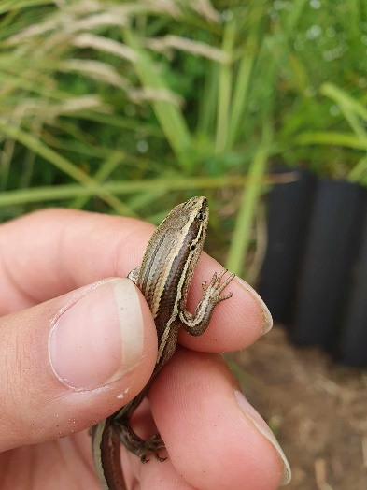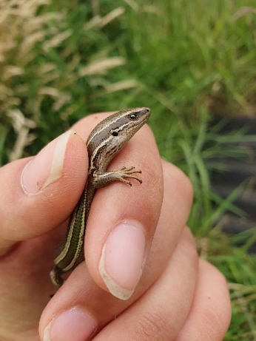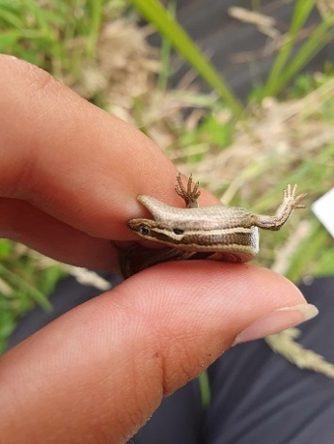

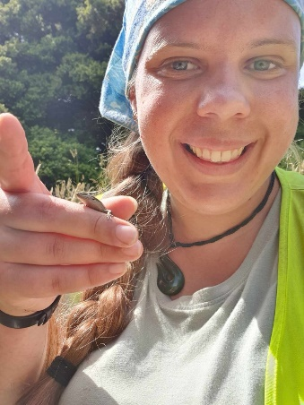I’ve got so much more that I could write about, but that would likely fill a book (or at least be a very long report). OTDF is such an awesome place, full of so many cool things and I’m very lucky to have been able to spend time out there. I finish up around the 14th of February. If anyone wants to come find me on the reserve and have a chat, or you’re more than welcome to get in contact (Maurice has my details).   
Elizabeth

Note Elizabeth’s photo of a copper butterfly on a ragwort flower head is the first record of these butterflies in the reserve. Copper butterflies are known to occur with muehlenbeckia.

**Weeding and Pest Control**

Dallas continues with is work controlling weeds, releasing plants, trialling and checking new lures and trapping/bait systems, rebaiting these as necessary. He also enters trap data collected by Tim, and rabbit hunt results to keep our list of pests caught and bait set out up to date and recorded below.



|  |  |  |
| --- | --- | --- |
| **Pest numbers** | Total to 31Jan 2024 | Number caught in Jan 2024 |
| Rats | 85 | 1 |
| Mice | 1683 | 11 |
| Possums | 97 | 2 |
| Ferrets | 3 | 0 |
| Stoats | 18 | 1 |
| Weasels | 11 | 2 |
| Rabbits | 273 | 14 |
| Feral Cats | 16 | 0 |
| Hedgehogs | 282 | 3 |
| Wasp Nest | 4 | 0 |
| Baits set out/replaced | 4326 | 26 |

**Comments:**

**Mice** – Catch numbers are still pretty low.

**Rats –** One caught.

**Bait –** A bit of consumption here and there. Mouldy bait replaced.

**Hedgehogs** – Only 3 hedgehogs this month. Still seeing a bit of scat on tracks.

**Rabbits** – 14 rabbits shot on one night. Still seeing a few in bush on trail cams.

**Possums** – Two caught, one in a cage trap and the other in a possum master. Probably still at least one around.

**Cats** – None caught but a few regulars (some of which are domestics) that won’t go into cage traps. Less sightings in trail cams this month than last.

**Mustelids –** 1 stoat caught in a cage trap but still seeing others in trail cams.

**Wasps** – No nests found.

**General –** See below for a selection of trail camera pictures.

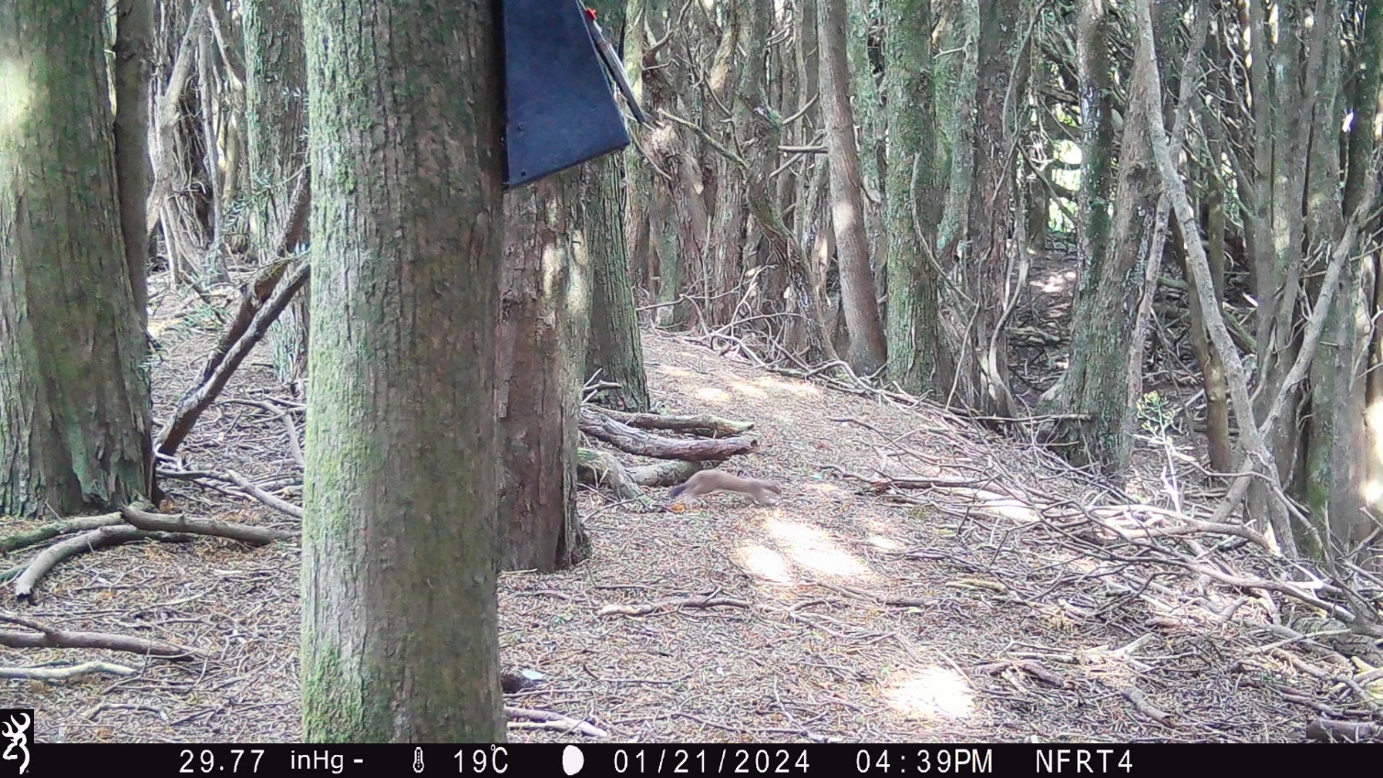

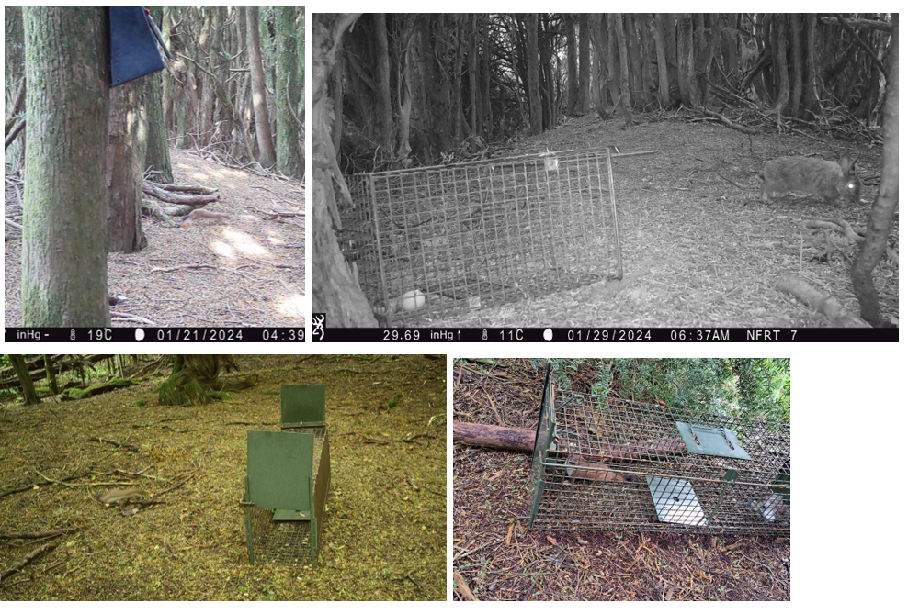

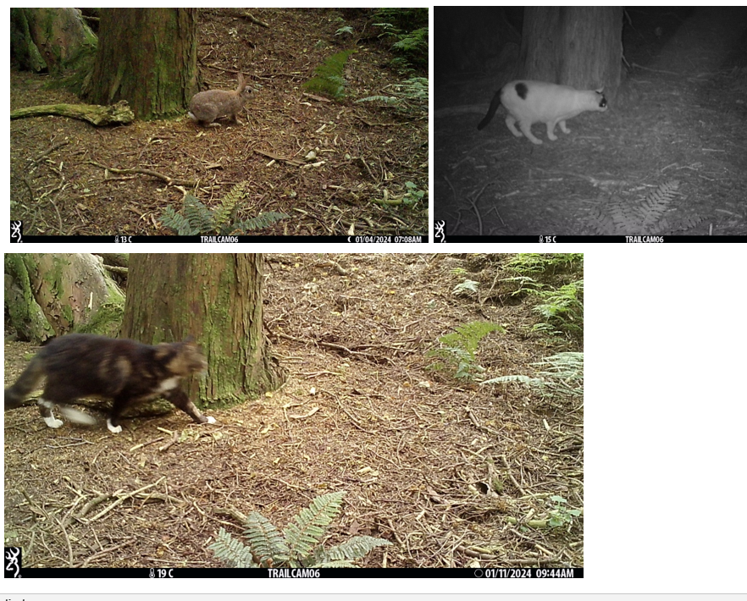

Pest captures are recorded on Trap NZ. To see the trap locations and other points of interest go to the website and log in then go to the Oreti Totara Dune Forest. Other data, e.g. bird counts, are there too.

**Track maintenance**

Tim has been mowing the main track and the track to the pond. Barry has been mowing tracks that are harder to access. Graeme has mowed the car park area.

**Visitor use**

The brochures and Canopy magazine have been replaced on Neil’s hut as required.

**Wetland Enhancement.**

The ephemeral wetlands have dried out and the whole site is fairly dry. Rainfall has been reasonable over the summer so far so we do not have a drought situation.

**Miscellaneous**

The ICC is preparing a management plan for Sandy Point which is just over the river from the reserve. I have made a submission asking for better control of fires as this is a big risk for the OTDF. There are large areas of pine forest there and if a large fire got hold in a strong westerly wind the reserve would be at risk.

**Volunteer contributions** Voluntary hours: Maurice 20, Dallas 29, Car park mowing and maintenance 4.

Total for Jan 2023 - 53, Total since June 1 2020, 2037

Maurice Rodway, Hon Ranger.