**Oreti Totara Dune Forest Report November 2023**

**Revegetation**

The ICC has discontinued its service of looking after small totara trees that we supplied to them from gardens in Otatara. I have collected these from them and left them at Rory’s property where he will look after them until they can be planted out. There are about 2000 plants there and some are big enough to plant out next planting season – winter when the soil is moist. Currently it is too dry unless they could be watered regularly. Rory will water them to keep them going till they can be planted out.

They will be planted in the grazed area as they are resistant to grazing and along with 200-300 flaxes to be planted annually in this area. Over time a totara forest will be established. Totaras only need to be planted about 10m apart, so that’s about 100 per ha and he has 20ha under grazing.

Here is a photo of the trees on Rory’s property. ( With guard dogs).

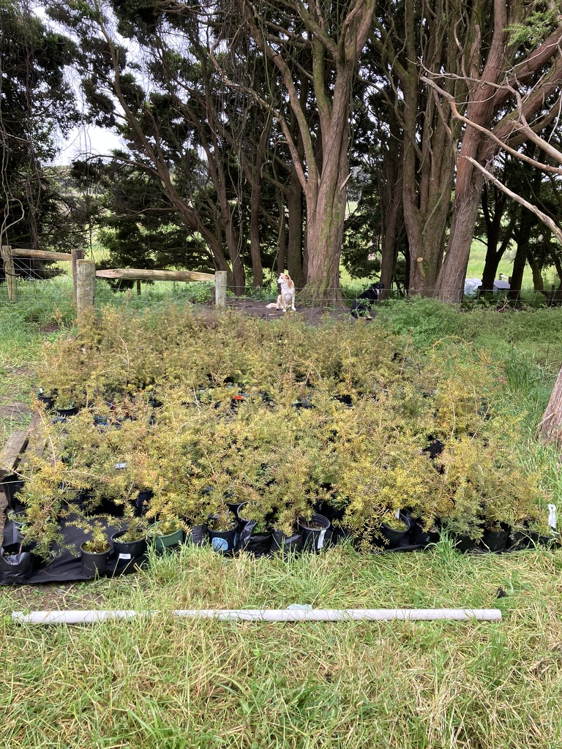

**Weeding and Pest Control**

Dallas continues with is work controlling weeds, releasing plants, trialling and checking new lures and trapping/bait systems, rebaiting these as necessary. He also enters trap data collected by Tim, and rabbit hunt results to keep our list of pests caught and bait set out up to date and recorded below.



|  |  |  |
| --- | --- | --- |
| **Pest numbers** | Total to 30 Nov 2023 | Number caught in Nov 2023 |
| Rats | 84 | 25 |
| Mice | 1655 | 91 |
| Possums | 95 | 3 |
| Ferrets | 3 | 0 |
| Stoats | 17 | 0 |
| Weasels | 9 | 0 |
| Rabbits | 247 | 12 |
| Feral Cats | 16 | 0 |
| Hedgehogs | 270 | 8 |
| Wasp Nest | 4 | 0 |
| Baits set out/replaced | 4248 | 39 |

**Mice** – Catch numbers generally low but quite a few caught in seldom trapped areas and areas where monitoring has indicated their presence.

**Rats –** 2 caught – a good decrease on recent months.

The quarterly rodent monitoring was undertaken once again – a good result (0% rats and 0% mice). However, at least one mouse was trapped 20 metres from a monitoring station the day after the monitoring. The monitoring results over time are depicted on the graph below.

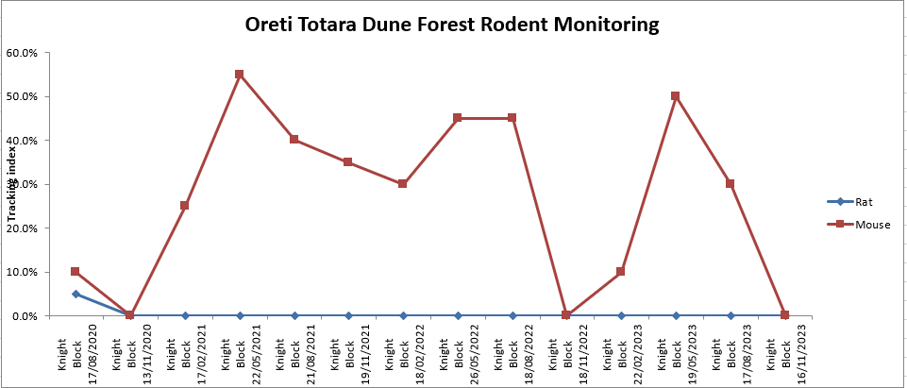

Bait – A bit of consumption here and there. Mouldy bait replaced.

Hedgehogs – 9 hedgehogs this month.

Rabbits – 12 rabbits shot on one night.

Possums – Three caught, two adult females and a juvenile.

Cats – None caught.

Mustelids – None caught.

Wasps – No nests found.

General – Trailcams are being redeployed. A few possums, cats and rabbits appearing. The possums are being despatched. Two of the cats are known “domestics” that like hunting, one being photographed 800 metres from home. I am sure that it catches a few rats, mice and small rabbits. Just what else they get, I wouldn’t know, a few ducklings perhaps and small non native birds too probably. Cage traps are being deployed again.

Pest captures are recorded on Trap NZ. To see the trap locations and other points of interest go to the website and log in then go to the Oreti Totara Dune Forest. Other data, e.g. bird counts, are there too.

Elizabeth and her partner Pomare started their work on the 27th with setting out of the skink monitoring homes and the pitfall traps. She also made a start on the five minute bird counts. And she has made a start on the flame creeper control.

Muelhenbeckia vine has been growing vigorously and a programme to control in limited areas in being planned. Only areas not exposed to the SW will be treated, the first area will be adjacent to the right of way just south of the first creek. Shown in the 4th photo below.

The other photos show issues associated with muelhenbeckia . The first is of an apparently healthy medium sized totara tree that has been broken and has fallen over. Its top is covered in muelhenbeckia. It is not certain that the vine caused it to collapse but it is possible. Totara trees can fall over and continue to live for many years. However the leaves of this one are completely smothered so will die. Other photos show the vine on a neighbouring property growing over tall trees but being browsed by sheep up as high as they can reach. Now that there are no grazing sheep or cattle on the block there is limited control of regrowth so some management is needed to avoid it taking over completely and smothering even tall totara trees that are open to the sun.

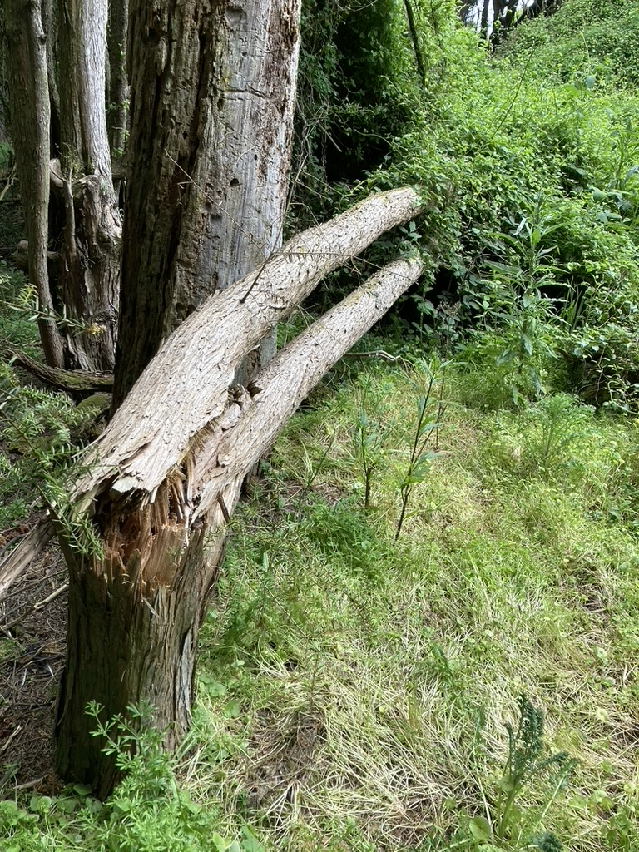

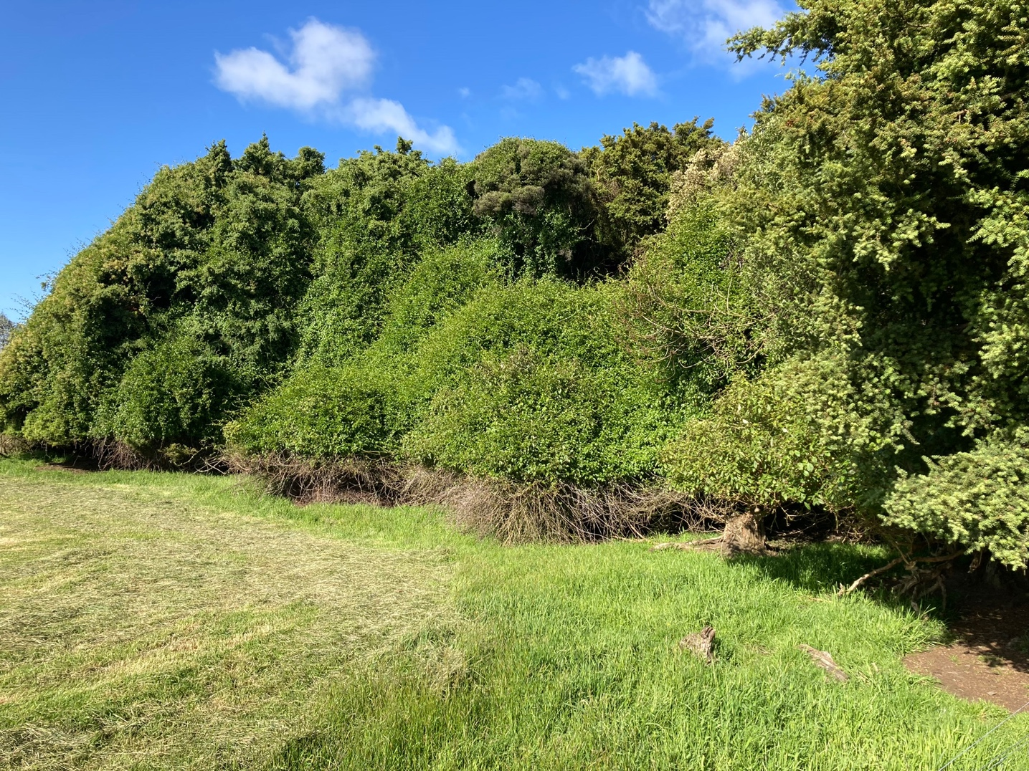

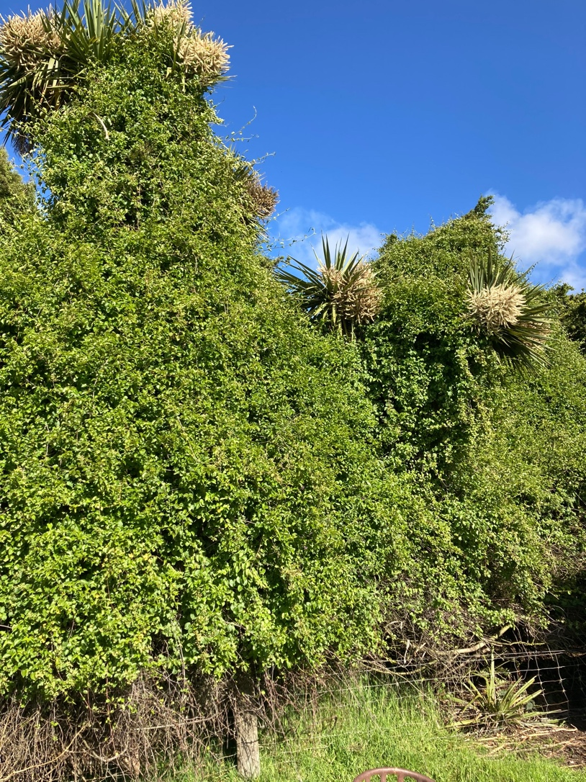

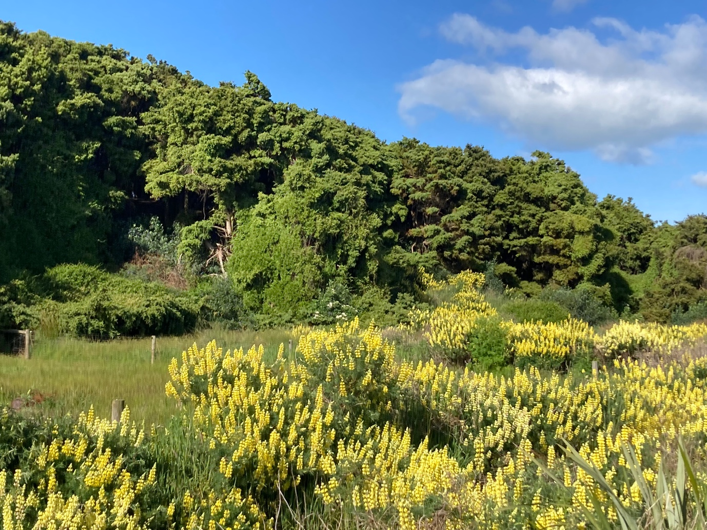

**Track maintenance**

Tim has been mowing the main track and the track to the pond. Barry has been mowing tracks that are harder to access. Graeme has mowed the car park area.

**Visitor use**

The brochures and Canopy magazine have been replaced on Neil’s hut as required. Cathy has initiated work on a display board to tell the story of pre European times in the area and we plan to commence work with local mana whenua in a joint project to complete this have contacted a local person from the Waihopai Runaka but have yet to hear back from them. The new seat has been made by Alan and put in place on the mingi mingi trail.

**Wetland Enhancement.**

The ephemeral wetlands have dried out and the whole site is fairly dry Rainfall has been sparse over the last month we are now slightly behind the average for the whole year at 1005 mm compared to the average of 1019 for the year to date. Rainfall for December is 2.4 mm compared to an average of 15 for December so far.

**Miscellaneous**

The ICC is preparing a management plan for Sandy Point which is just over the river from the reserve. One thing I will be submitting on is for better control of fires as this is a big risk for the OTDF. There are large areas of pine forest there and if a large fire got hold in a strong westerly wind the reserve would be at risk.

**Volunteer contributions** Voluntary hours: Maurice 18, Dallas 11, Car park mowing and maintenance 2.

Total for Nov 2023 - 31, Total since June 1 2020, 1985.

Maurice Rodway, Hon Ranger.